**IoT Network Architecture and Design**

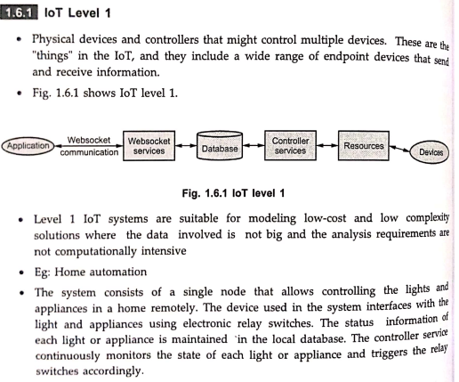

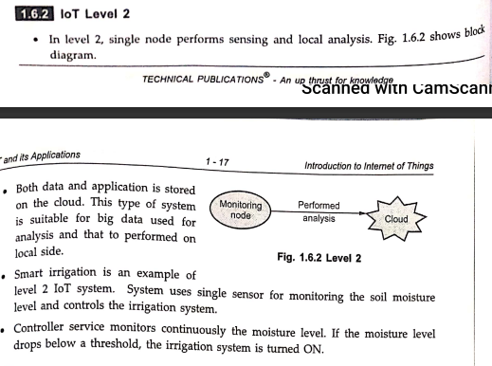

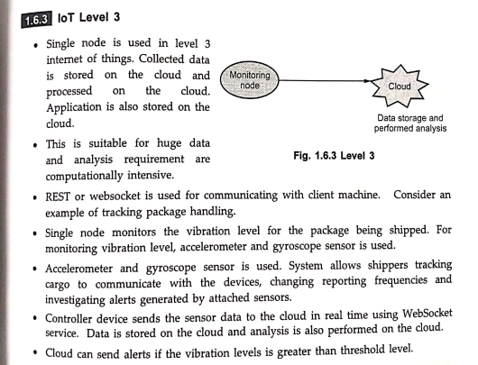

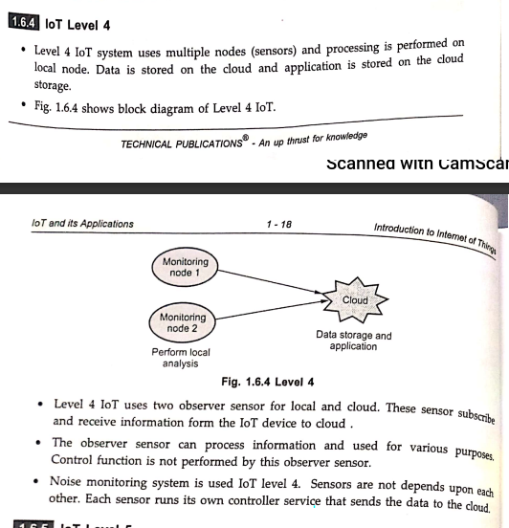

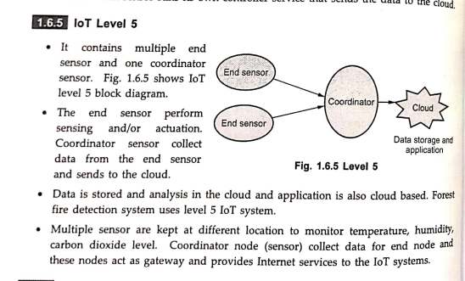

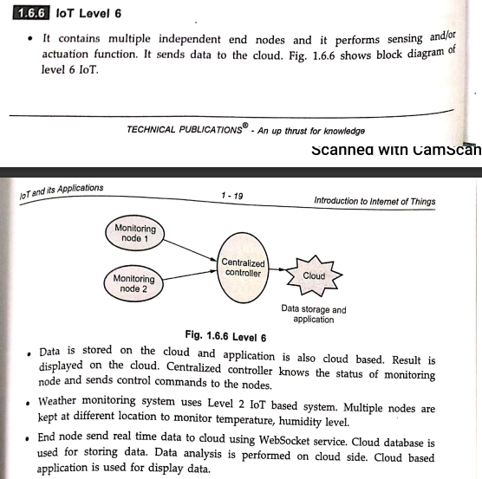

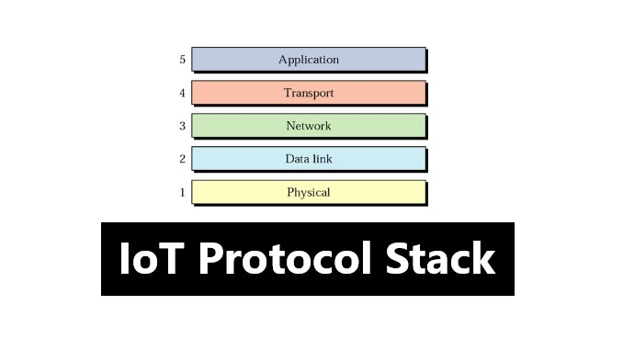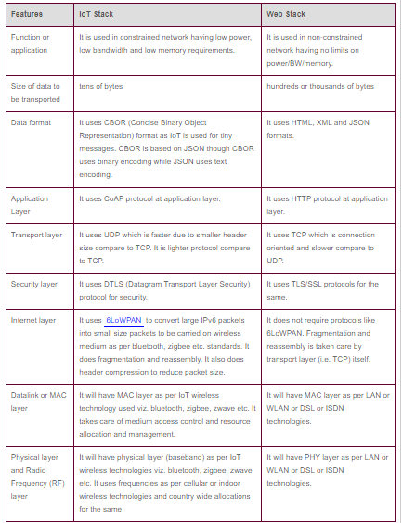

**Advantages of IoT**

Internet of things facilitates the several advantages in day-to-day life in the business sector. Some of its benefits are given below:

1. **Efficient resource utilization**: If we know the functionality and the way that how each device work we definitely increase the efficient resource utilization as well as monitor natural resources.
2. **Minimize human effort**: As the devices of IoT interact and communicate with each other and do lot of task for us, then they minimize the human effort.
3. **Save time**: As it reduces the human effort then it definitely saves out time. Time is the primary factor which can save through IoT platform.
4. **Enhance Data Collection:**
5. **Improve security**: Now, if we have a system that all these things are interconnected then we can make the system more secure and efficient.

**Disadvantages of IoT**

As the Internet of things facilitates a set of benefits, it also creates a significant set of challenges. Some of the IoT challenges are given below:

1. **Security**: As the IoT systems are interconnected and communicate over networks. The system offers little control despite any security measures, and it can be lead the various kinds of network attacks.
2. **Privacy**: Even without the active participation on the user, the IoT system provides substantial personal data in maximum detail.
3. **Complexity**: The designing, developing, and maintaining and enabling the large technology to IoT system is quite complicated.